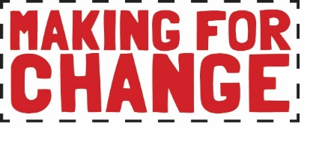

Youth Artist Digital Residency Application

Please read or listen to the residency brief before completing this application form. To watch a video explaining the application process, please click here.

Email your application to info@craftspace.co.uk with the subject title ‘Artist Residency Application’ by 9am Monday 6th June 2022. You may choose to answer the questions by video if you prefer.

Click here to complete your Equal Opportunities Form online or download as a word document from Craftspace website Team page.

About You

Name:
Preferred pro-noun (e.g. he/him, she/her, they/them):
Date of Birth:
Address:
Mobile/Telephone number:
Email:
Website/Portfolio:
Social media (work):

Do you have any specific interests, knowledge or qualifications (including arts practice) that relate to this role (250 words max)?

Do you have any previous experience (paid or voluntary) that relates to this role (200 words max)?

What would you like to gain from this residency? (200 words max)?

Access
Please tell us about any access needs for which you will require additional support:

Time Commitments
Please tell us about any time commitments you will have from July 2022 up to and including December 2022 (work, study, holiday or other commitment):

Interview
Will you be available to attend a zoom interview on either Wednesday 15th or Thursday 16th June 2022?

We will send you the questions in advance.
Candidates invited to interview will need to provide proof of their right to work in the UK.
Planning meeting
Will you be available to attend an induction/planning meeting (either physical or online) on Wednesday 6th or Thursday 7th July 2022

Email your application to info@craftspace.co.uk by 9am on Monday 6th June 2022. Include your:
- completed application form OR a video which answers the questions from the form.
- one example (a link or an image - size 1MB at 300dpi) of a digital or online project you have worked on, please let us know what the project was about and your role in it. This could be a website, artwork, performance piece, social media account or marketing campaign.

Privacy Notice
Craftspace is registered as a data controller. (Registration Number: Z5906900) Craftspace tries to meet the highest standards when collecting and using personal information in accordance with data protection law. Read and download our full privacy notice on our website.

craftspace.co.uk
Unit 15, Highgate Craft Centre, 8 Highgate Square, Birmingham B12 0DU
TEL 0121 608 6668 E-MAIL info@craftspace.co.uk

