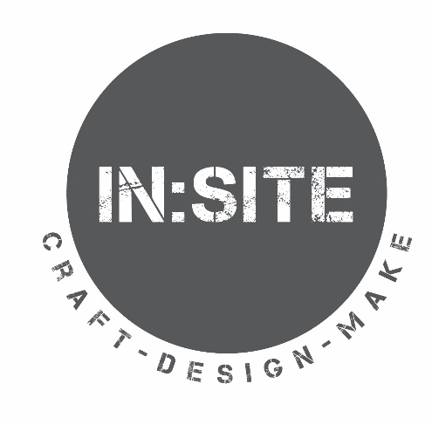

In:Site Film Maker Application 2022

Please read the Film Maker Opportunity Brief before completing this application form. If you prefer, you can make a short video that answers the questions on the form.

About You
Name |  | Are you over 18?
Address |  | Postcode
Email |  | Phone

9th – 13th May 2022

Are you available for these time slots for filming each day?
(please tick which sessions you can attend) | Mon | Tue | Wed | Thu | Fri
1 – 4pm
1 – 4pm
1 – 4pm
1 – 4pm
1 – 4pm

Are you able to attend a briefing meeting on Wednesday 27th April 2022 at 10.30am-12pm? (please highlight)
Yes No

Why are you interested in this opportunity and what skills and/or experience can you bring to the role?

What equipment will you be using to film and edit?

Please provide links to any films you have made:

Access
Craftspace welcomes applications from all sections of the community and will consider making reasonable adjustments to enable people to work effectively with us. If you have access needs please indicate your requirements.

Referee
Please provide contact details of your most recent employer or education institution.
Name of  Referee | Job Title | Address | Telephone/email

Signature

Signed: | Date:

Please send this form to: Administrative Assistant, Craftspace, Unit 15 Highgate Craft Centre, 9 Highgate Square, Birmingham, B12 0DU or info@craftspace.co.uk by Tuesday 19th April 2022 at 5pm.

Thank you

