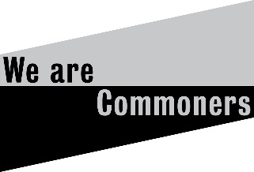

We are Commoners: Creative acts of commoning
Launch  26 March 2021  Exhibition  26 March  - 26 June 2021  Oriel Davies Gallery  Newtown  Then touring until September 2022 | 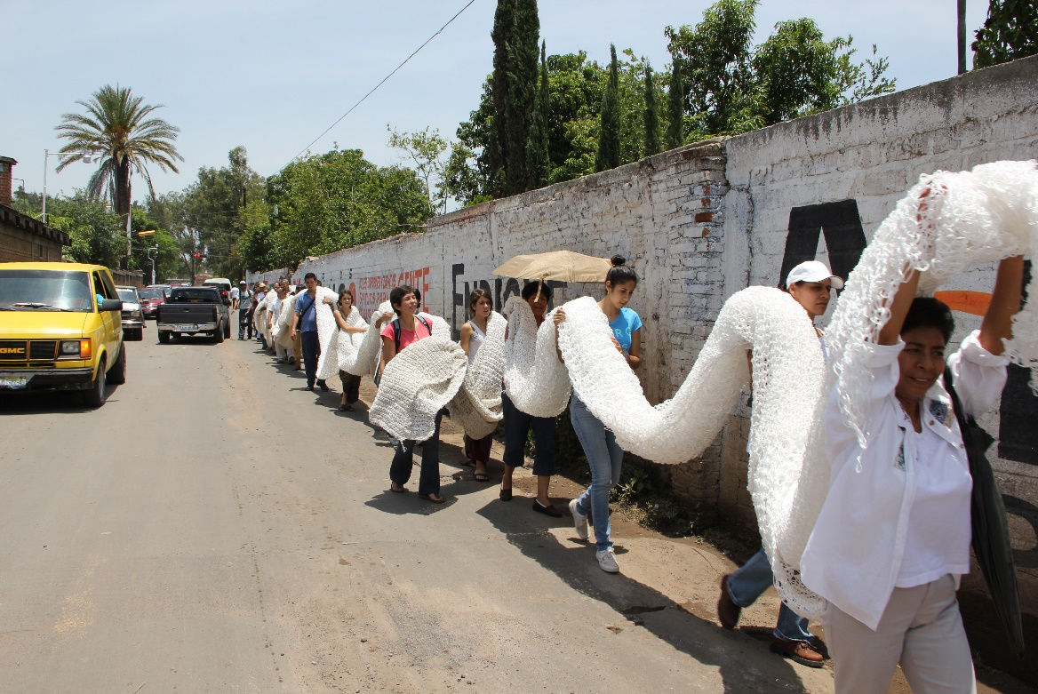
Claudia Rodríguez and
Ana Joaquina Ramírez
REDES Project Procession
Photo: Metztli Cerda

A new exhibition shows how shared processes, skills and values associated with creative making contribute to thriving commons neighbourhoods.
“The commons means: Things we share/ Places we share/ Systems we share/ Ideas we share/ Culture we share” Peter Barnes, On the Commons co-founder
This thought-provoking Craftspace national touring exhibition, launching this March at Oriel Davies Gallery, Newtown highlights ‘acts of commoning’. These actions are shaping the way communities work together to share and steward commonly owned assets and resources. Through sixteen loans and new commissions artists will bring attention to the issues, contribute their thought leadership and participate in a call to action. These artists provide a powerful commentary on what society stands to gain from acting to protect and reclaim our global commons.
Featuring both UK based and international artists, the exhibition reflects a commons-based shift in thinking from ‘you’re on your own’ to ‘we’re in this together.’ It will investigate how creativity, making and materials can highlight how acts of commoning are creating thriving communities.
“In a time of extreme disruption from COVID-19, this exhibition provides a mutual resource to find and process meaning out of trauma and loss, to aid recovery. Lockdown has seen a surge in purchase of craft equipment and materials. People have turned to age-old craft skills and making to get by, boost their resilience and engage in acts of collective creativity. Increasing privatisation in cities has eroded the commons and local authorities are hard pressed to steward commonly owned spaces and assets. Now more than ever we need Commons thinking to rebalance our ways of being, living, working and imagining a more collectively-made and owned future.” Deirdre Figueiredo MBE, Director, Craftspace
Exhibition themes range from work influenced by historical land based commons, such as the Common Ground Peckham Rye Token project by Alice McLean and Justine Boussard and stained glass ‘Rewilding at the Clootie Tree’ by Pinkie Maclure to fashion commons where Amy Twigger Holroyd shares stitch hacking techniques in Re:Knit Revolution. Collectively made textiles from the Embroidered Digital Commons, coordinated by Ele Carpenter, considers the internet as a shared resource, whilst Lise Bjørne Linnert and Gelawesh Waledkhani investigate ideas of mobile commons with undocumented migrants in Norway. Sharing resources and ideas, including food production are explored by Rachael Colley and Jacky Oliver. Linda Brothwell will create a new iteration of her project ‘Acts of Care: Bench Repair’ through repairing benches for public places with beautiful wooden inlays. Deirdre Nelson maps local acts of commoning around the streets where she lives in Glasgow.
Shane Waltener is making scaffold structures from locally sourced willow, bramble and handmade nettle and flax twine. They are a physical and metaphorical means of thinking through: shared resources, issues relating to enclosure and rights of access. He draws attention to craft skills and nature itself, as forms of commons.
“I am creating a performance installation as ‘a symbolic act of repair’, one that prompts us to rethink our connections between land and materials, making a connection between the urban and the rural, learning from nature and landscape and in doing so, rewrite narratives and imaginaries relating to all of the above.” Shane Waltener
Claudia Rodríguez and Ana Joaquina Ramírez collaborated, supported and supervised by Rosina Santana Castellón, to bring different communities together with a focus on the polluted Santiago river affecting cities and agriculture, in Guadalajara, Mexico. The polluted water had caused cases of cancer in poor neighbourhoods next to it. This had caused division and suspicion in the community. PROYECTO REDES (NET PROJECT) activated the whole community in protest and resulted in a monumental collective weave woven by urbanites and villagers. The project empowered and engaged many and successfully built bridges among them to create awareness of their rights and a stronger resistance.
Also on show, three artists have worked in response to or co-created with communities in three UK place-based and socially engaged residencies in Birmingham, St Helens and Newtown.

Visiting
We are Commoners will launch at Oriel Davies Gallery in 2021 and tour throughout the UK. The exhibition is free to visit. More details at commoners.craftspace.co.uk.

ENDS

More information and images
Emma Daker, Exhibitions organiser: e.daker@craftspace.co.uk
Deirdre Figueiredo, Director: d.figueiredo@craftspace.co.uk
Lisa Falaschi, Marketing assistant: l.falaschi@craftspace.co.uk
Phone: 0121 608 6668

Editors Notes

Online
Project blog: commoners.craftspace.co.uk
# WeAreCommoners
 craftingcommons
 craftspace
 tweetcraftspace
 craftspace_

Filming and interview opportunities
Artists and exhibition organisers are available for interview. It may be possible to arrange visits to makers who are working on their commissions.

Date: Press release published January 2021

Artists
Amy Twigger Holroyd; Ele Carpenter; Claudia Rodríguez & Ana Joaquina Ramírez supported and supervised by Rosina Santana Castellón; Deirdre Nelson; Fourthland: Isik Sayarer and Eva Knutsdotter; Linda Brothwell; Pinkie Maclure; Heidi Hinder; Blackwater Polytechnic: (a collaboration created by Ben Coode-Adams and Freddie Robins), Justin Knopp, Sara Impey, Simon Emery; Alice McLean & Justine Boussard; Jacky Oliver; Lise Bjørne Linnert & Gelawesh Waledkhani; Rachael Colley and Common Agency Projects (Shane Waltener & Laura Glaser).
Three place-based and socially engaged residencies will result in artworks made in response to or co-created with communities: Alinah Azadeh created an online resource in partnership with Craftspace, MAC Birmingham and St Paul’s Community Development Trust, in Birmingham. Kate Hodgson is working with young women in St Helens in partnership with Heart of Glass and Hefin Jones is working with young people in Newtown in partnership with Oriel Davies Gallery.

Tour schedule

Oriel Davies Gallery, 26 March – 26 June 2021
Leicester Gallery, De Montfort University, 10 July – 4 September 2021

Devon Guild of Craftsmen , 18 September – 14 November 2021,

The Civic, Barnsley, 5 February – 23 April 2022
National Centre for Craft & Design, 7 May – 10 July 2022

Research
Crafting the Commons is a Research Network led by Nottingham Trent University in partnership with Craftspace. Artists in the exhibition and academics from a range of disciplines are taking part in workshops, discussions and exchange. It is funded by the Arts and Humanities Research Council. A blog can be found at commoners.craftspace.co.uk.

What are the commons?
“The Commons are life-sustaining or life-enhancing resources and services that have not been divided up and assigned a monetary value in the global economy but instead are shared - according to evolving arrangements and agreements - among members of a community or group. They range from the air we breathe, pollination provided by bees, land that provides food for gathering, sharing, cultivating and dwelling rather than selling, to libraries, public parks, pavements we walk along, and on to childcare, care for the elderly and words of comfort given freely and willingly rather than at an hourly rate.” Commons Thinking, Justin Kenrick

COVID 19
These details are subject to change as organisations follow updated government advice. They are correct at the time of publishing and this project is due to go ahead as planned in March 2021.

Funding
A national touring exhibition curated by Craftspace, funded by Arts Council England. A grant was also received from the Mexican Embassy in the UK for their Cultural Programme to support the inclusion of Claudia Rodríguez in the exhibition.
New work, created as part of the residency in Newtown and online during the pandemic, was supported by The National Lottery through the Arts Council of Wales.

Craftspace: craftspace.co.uk
Craftspace is a charity creating opportunities to see, make and be curious about exceptional contemporary craft. We are based in Birmingham and work collaboratively regionally, nationally and internationally. We build relationships between artists, people and organisations and encourage the sharing of ideas, skills and knowledge.
We have 30+ years’ experience and continue to learn, push boundaries and challenge ideas. Craftspace initiates artistic programmes which stimulate creative excellence, critical thinking and understanding of contemporary crafts in the widest social and cultural contexts.

Arts Council England
Arts Council England is the national development body for arts and culture across England, working to enrich people’s lives. We support a range of activities across the arts, museums and libraries – from theatre to visual art, reading to dance, music to literature, and crafts to collections. Great art and culture inspires us, brings us together and teaches us about ourselves and the world around us. In short, it makes life better. Between 2018 and 2022, we will invest £1.45 billion of public money from government and an estimated £860 million from the National Lottery to help create these experiences for as many people as possible across the country. www.artscouncil.org.uk

Craftspace
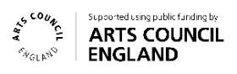
Tel: 0121 608 6668
info@craftspace.co.uk
craftspace.co.uk
 craftspace
 tweetcraftspace
 craftspace_

