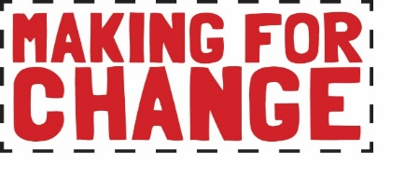

Making My Mark Application
Shadow Artist - Digital

Please read the job description before completing this application form.

Email your application to info@craftspace.co.uk by 9am on Monday 22nd February 2020. You may choose to answer the questions by video if you prefer.

Click here to complete your Equal Opportunities Form online or download as a word document from Craftspace website Team page.

About You

Name:
Preferred pro-noun (e.g. he/him, she/her, they/them):
Date of Birth:
Address:
Mobile/Telephone number:
Email:
Website/web spaces (work)
Social media (work):

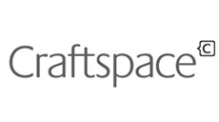
Please tell us why you are applying for this role (100 words max):

What would you like to gain from this role and how will it help your future career development (150 words max)?

Do you have any specific interests, knowledge or qualifications that relate to this role (150 words max)?

Do you have any previous experience (paid or voluntary) that relates to this role (150 words max)?

Access
Please tell us about any access needs for which you will require additional support:

Time Commitments
Please tell us about any time commitments you will have from February 2021 up to and including May 2021 (work, study, holiday or other commitment):

Interview
Will you be available to attend a zoom interview on Wednesday 24th February 2020?

We will send you the questions in advance.
Candidates invited to interview will need to provide proof of their right to work in the UK.

Planning meeting
Will you be available to attend a planning meeting on Monday 1st March 2020?

Email your application to info@craftspace.co.uk by 9am on Monday 22nd February 2020. Include your:
- completed application form OR a video which answers the questions from the form.
- one example (a link or an image - size 1MB at 300dpi) of a digital or online project you have worked on. This could be a website, artwork, design work, social media account or marketing campaign.
Privacy Notice
Craftspace is registered as a data controller. (Registration Number: Z5906900) Craftspace tries to meet the highest standards when collecting and using personal information in accordance with data protection law. Read and download our full privacy notice on our website.

craftspace.co.uk
Unit 15, Highgate Craft Centre, 8 Highgate Square, Birmingham B12 0DU
TEL 0121 608 6668 E-MAIL info@craftspace.co.uk

